SymptoSense AI: A Multi-Agent Health Symptom Analytics, Risk Prediction, and Care Routing Ecosystem
A Mini Project Report Submitted in partial fulfilment of the requirements
for the award of the degree of
BACHELOR OF TECHNOLOGY
in
DEPARTMENT OF COMPUTER SCIENCE AND ENGINEERING
By
B. Vignesh Reddy — 2420030285
P. Karthik — 2420030404
P. Sowmya — 2420030457
Under the Esteemed Guidance of
Dr. Srikanth Cherukuvada





K L (Deemed to be) University
DEPARTMENT OF COMPUTER SCIENCE ENGINEERING
Or
DEPARTMENT OF COMPUTER SCIENCE AND INFORMATION TECHNOLOGY

DECLARATION

The Mini Project Report entitled "SymptoSense AI: A Multi-Agent Health Symptom Analytics, Risk Prediction, and Care Routing Ecosystem" is a record of bonafide work carried out by B. Vignesh Reddy (2420030285), P. Karthik (2420030404), P. Sowmya (2420030457), submitted in partial fulfilment of the requirements for the award of the degree of Bachelor of Technology in Computer Science and Engineering to K L University. The results presented in this report have not been copied from any other department, university, or institute.

B. Vignesh Reddy - 2420030285
P. Karthik - 2420030404
P. Sowmya - 2420030457

K L (Deemed to be) University
DEPARTMENT OF COMPUTER SCIENCE ENGINEERING
Or
DEPARTMENT OF COMPUTER SCIENCE AND INFORMATION TECHNOLOGY
CERTIFICATE

This is to certify that the mini project-based report entitled "SymptoSense AI: A Multi-Agent Health Symptom Analytics, Risk Prediction, and Care Routing Ecosystem" is a bona fide work done and submitted by B. Vignesh Reddy (2420030285), P. Karthik (2420030404), P. Sowmya (2420030457), in partial fulfilment of the requirements for the award of the degree of Bachelor of Technology in the Department of Computer Science and Engineering, K L (Deemed to be) University, during the academic year 2026 - 2027.

Signature of the Course Co-ordinator Signature of HOD

ACKNOWLEDGEMENT

The success in this project would not have been possible but for the timely help and guidance rendered by many people. Our wish to express my sincere thanks to all those who has assisted us in one way or the other for the completion of my project.

Our greatest appreciation to my guide, Dr. Srikanth Cherukuvada, Department of Computer Science which cannot be expressed in words for his/her tremendous support, encouragement and guidance for this project.

We express our gratitude to Dr. P.Venkateshwar Sir (CSE)/Dr. Kaja Shareef Sir (CSIT), Head of the Department for Computer Science Engineering/ Department for Computer Science and Information Technology for providing us with adequate facilities, ways and means by which we are able to complete this project-based Lab.

We thank all the members of teaching and non-teaching staff members, and also who have assisted me directly or indirectly for successful completion of this project. Finally, I sincerely thank my parents, friends and classmates for their kind help and cooperation during my work.

B. Vignesh Reddy - 2420030285
P. Karthik - 2420030404
P. Sowmya - 2420030457

TABLE OF CONTENTS

S.No. | Contents | Page no.
1. | Abstract | 6
2. | Introduction | 7
3. | Literature survey | 8
4. | Problem Statement and Objectives | 9
5. | Hardware and Software requirements | 10
6. | Implementation | 11-16
7. | Results & Discussion | 17
8. | Conclusion & Future Scope | 18
9. | References | 19

- ABSTRACT

Emergency departments worldwide are routinely overcrowded, and a large share of walk-in patients do not actually need emergency-level care — many could have been guided earlier toward self-care or a scheduled consultation instead. Existing symptom-checker tools do little to solve this: most rely on rigid yes/no question trees, cannot interpret a patient describing several symptoms in everyday language, and give no explanation for their suggestions, leaving both patients and clinicians unable to trust them.
SymptoSense AI addresses this gap through a multi-agent, service-oriented triage system. Rather than one monolithic program, three independent AI agents each handle a single responsibility and communicate through a service-oriented backbone. The Symptom Analytics Agent interprets free-text, colloquial symptom input — correcting typos and recognising everyday phrasing — and expands it into a fuller, structured symptom profile. The Risk Prediction Agent classifies this profile against twenty-eight clinical conditions using a trained machine learning model, returning a differential of the most likely conditions with confidence scores instead of a single unexplained verdict, while an independent rule-based safety-override layer escalates known emergency symptom combinations regardless of model confidence. The Care Routing Agent then converts this into a concrete recommendation: emergency care, a scheduled appointment, or self-care guidance.
The pipeline is deployed as an authenticated, service-oriented microservices mesh featuring a service registry, an API gateway, JWT-based role access, and an event broker, so the system can scale and be maintained the way real clinical software is. SymptoSense AI is not a diagnostic replacement for a doctor; it is an explainable first-level triage assistant that helps users judge urgency and take the right next step, directly supporting SDG 3: Good Health and Well-Being.
Team Name: SymptoSense AI
Team Members:
1. B. Vignesh Reddy - 2420030285
2. P. Karthik - 2420030404
3. P. Sowmya - 2420030457

- INTRODUCTION

Deciding whether a symptom needs a hospital visit, a scheduled appointment, or simply rest at home is a judgement most people are not equipped to make confidently. This uncertainty pushes many patients toward the emergency room even when their condition is not urgent, while others delay care for symptoms that genuinely need prompt attention. The result is overcrowded emergency departments on one side and preventable health deterioration on the other.
Symptom-checker applications exist to close this gap, but the common ones fall short in practice. Most work through a fixed decision tree of yes/no questions, cannot make sense of a patient typing several symptoms together in plain language, and present their output as a single verdict with no explanation of how it was reached — which makes the result difficult for a patient or a clinician to trust.
SymptoSense AI was built to address this directly. Instead of one large program trying to do everything, the system is split into three focused AI agents — Symptom Analytics, Risk Prediction, and Care Routing — each responsible for one stage of the triage decision and connected through a service-oriented architecture (SOA). This mirrors how real healthcare software is engineered: as independently deployable services that communicate over well-defined contracts rather than as a single tightly coupled application.
The remainder of this report covers related work in the symptom-checking space, the problem statement and objectives the project set out to meet, the hardware and software used, a walkthrough of the frontend, backend, and SOA implementation, the results obtained from testing the system end-to-end, and the conclusions and future scope of the work.

- LITERATURE SURVEY
A review of existing symptom-assessment and triage platforms was carried out to understand current practice and to identify the gaps SymptoSense AI aims to close. A summary of seven comparable systems is given below; full references are listed in Section 9.
1. Ada Health. Ada Health is a widely used AI-based symptom assessment application that asks a patient a structured sequence of questions and estimates probable conditions using a probabilistic reasoning engine. It is one of the most downloaded symptom-checker apps globally, but like most consumer tools of this kind, it functions as a single assessment engine rather than a set of coordinated, independently reasoning agents, and it does not expose a safety-override layer that a developer can inspect separately from the main model.
2. Buoy Health. Buoy Health offers a conversational AI symptom checker that guides the patient through a chat-style interaction and narrows down likely causes before recommending a care pathway (self-care, primary care, urgent care, or emergency room). It demonstrates the value of natural, conversational symptom entry, which directly informed SymptoSense AI's decision to accept free-text, colloquial symptom descriptions rather than a fixed checklist.
3. Infermedica. Infermedica provides a medical AI engine and API that hospitals, insurers, and telehealth platforms integrate into their own products for symptom checking and triage. Its service-based, API-first delivery model is close in spirit to the SOA approach used in this project, where each triage capability is exposed as an independent, callable service rather than bundled into one application.
4. K Health. K Health is an AI-driven primary-care app that compares a patient's reported symptoms against millions of anonymised historical patient records to estimate likely conditions. It highlights the importance of grounding predictions in real clinical data; SymptoSense AI follows the same principle using a structured, per-disease symptom profile to train its classifiers, acknowledging synthetic data as a placeholder for real clinical data.
5. WebMD Symptom Checker. The WebMD Symptom Checker is a widely known rule-based tool that maps a selected set of symptoms to a static list of possible conditions. It is simple and fast but offers no risk tiering, no differential ranking, and no reasoning for its output — the exact limitations that motivated SymptoSense AI's differential-diagnosis and explainable risk-scoring design.
6. Mayo Clinic Symptom Checker. Mayo Clinic, a leading medical institution, offers a decision-tree style self-assessment tool that routes users through condition-specific question branches. It is clinically conservative and trustworthy, but like WebMD's tool, it is not adaptive to free-text input and does not provide a confidence-ranked differential, which SymptoSense AI set out to improve on.
7. NHS 111 Online. The UK National Health Service's NHS 111 Online service provides triage and care routing for non-emergency symptoms, directing patients to self-care, a pharmacy, a GP, or emergency services. Its three-tier routing model (self-care / scheduled care / emergency care) closely parallels the Low / Moderate / High risk tiers used by SymptoSense AI's Care Routing Agent.

- Problem Statement and Objectives

Problem Statement:
Patients lack an accessible, explainable way to judge the urgency of their symptoms before deciding where to seek care.

Problem Description:
Existing symptom-checker tools rely on rigid question trees, cannot interpret everyday language, and give no reasoning for their output — leading either to dangerous delay in seeking care or unnecessary burden on emergency services.

Objectives:
•Build a Symptom Analytics Agent that understands free-text, everyday symptom descriptions — including typos and colloquial phrasing — and expands them into a structured symptom profile.
•Build a Risk Prediction Agent that classifies the symptom profile against a defined set of clinical conditions and returns a ranked differential diagnosis with confidence scores, not a single forced answer.
•Implement an independent, rule-based safety-override layer that guarantees known high-risk symptom combinations are escalated correctly, regardless of model confidence.
•Build a Care Routing Agent that converts the predicted risk tier into a clear, actionable next step for the patient.
•Deploy the three agents as an authenticated, service-oriented microservices mesh with service discovery, an API gateway, JWT-based access control, and an event broker, in line with SOA principles.
•Validate the complete pipeline end-to-end against realistic symptom scenarios and measure the classification accuracy of each model.

- HARDWARE AND SOFTWARE REQUIREMENTS

Hardware Requirements:
•A standard laptop or desktop computer (minimum 8 GB RAM recommended)
•A stable internet connection, for installing dependencies and testing APIs
•No specialised medical or IoT hardware is required — SymptoSense AI is a fully software-based system

Software Requirements:
•Python 3.10+ — backend services and machine learning agents
•FastAPI and Uvicorn — REST API framework and ASGI server for every microservice
•scikit-learn, pandas, numpy, joblib — model training, data handling, and model serialisation
•PyJWT — issuing and validating JSON Web Tokens for authentication
•SQLite — lightweight relational storage, one database per microservice
•HTML5, CSS3, JavaScript (ES6) — the frontend triage dashboard
•Visual Studio Code — primary development environment
•Postman — manual and automated API testing
•Git and GitHub — version control and continuous evaluation submission

- IMPLEMENTATION
1. Frontend (HTML, CSS, JavaScript)

Everything lives in one file: frontend/index.html (709 lines — layout, styling and logic together, no separate .css/.js files).

HTML — page structure (frontend/index.html)

html
<aside class="sidebar">
<div class="brand">
<div class="mark">...</div>
<div><h1 class="display">SymptoSense</h1><div class="tag">Multi-agent triage</div></div>
</div>
<nav class="side-nav">
<button class="active" data-view="check">New Check</button>
<button data-view="history">History</button>
<button data-view="about">How it works</button>
</nav>
</aside>

CSS — design tokens, embedded in <style> (lines 9–241)

css
:root{
--bg:#EEF2F0; --panel:#FFFFFF; --sidebar:#10251F;
--primary:#14524A; --accent:#C9A24A;
--high:#A8402C; --mod:#A9781F; --low:#23755A;
}
body{
margin:0; background:var(--bg); color:var(--ink);
font-family:'IBM Plex Sans', sans-serif; font-size:15px;
display:flex; min-height:100vh;
}
aside.sidebar{
width:230px; background:var(--sidebar); color:#EAF1EE;
display:flex; flex-direction:column; padding:26px 18px;
position:sticky; top:0; height:100vh;
}

JavaScript — calls the live backend, embedded in <script> (lines 412–707)

javascript
const API_BASE = "http://localhost:8000";
let backendOnline = false;

async function checkBackend(){
try{
const r = await fetch(API_BASE + "/health", { signal: AbortSignal.timeout(1500) });
backendOnline = r.ok;
}catch(e){ backendOnline = false; }
document.getElementById('side-dot').className =
'dot-ind ' + (backendOnline ? 'on' : 'off');
}
checkBackend();

function toApiKey(s){ return s.trim().toLowerCase().replace(/\s+/g,'_'); }
2. Backend (Python – FastAPI)

The template’s section header says “Backend (JAVA)” — kept honest here as Python/FastAPI since that’s the version that was actually built and tested end-to-end (the Java/Spring Boot layer exists only as an uncompiled reference, noted separately).

File What it does
backend/main.py FastAPI route handlers — the 3 agent endpoints
backend/profiles.py 28 disease profiles, symptom list, red-flag combos
backend/aliases.py colloquial → canonical symptom alias map
backend/match.py fuzzy/compound-phrase symptom matching
backend/generate_dataset.py synthesises the 14,000-row training set
backend/train_agents.py trains & saves the two .pkl models

main.py — Agent 2 endpoint (differential risk prediction with safety override)

python
@app.post("/api/risk/predict")
def predict_risk(req: RiskRequest):
vec, matched, unrecognized = to_vector(req.symptoms)
if not matched:
raise HTTPException(status_code=400, detail="No recognizable symptoms to assess risk for.")
proba = disease_model.predict_proba(vec.reshape(1, -1))[0]
classes = disease_model.classes_

ranked = sorted(zip(classes, proba), key=lambda cp: -cp[1])
top3 = [
{"disease": c, "confidence": round(float(p), 3), "risk_level": DISEASE_PROFILES[c]["risk"]}
for c, p in ranked[:3] if p > 0.01
]
primary = top3[0]

# Safety override: check matched symptoms against known red-flag combos
matched_set = set(matched)
safety_triggered = any(combo.issubset(matched_set) for combo in RED_FLAG_COMBOS)
final_risk = primary["risk_level"]
if safety_triggered and RISK_ORDER[final_risk] < RISK_ORDER["High"]:
final_risk = "High"

return {
"disease": primary["disease"], "risk_level": final_risk,
"confidence": primary["confidence"],
"safety_override_triggered": safety_triggered,
"differential": top3,
"all_probabilities": {c: round(float(p), 3) for c, p in zip(classes, proba)},
}
3. API Integration (SOA layer)
File Role
soa/registry/main.py service registry (self-register + heartbeat)
soa/broker/main.py event broker (publish/consume by topic)
soa/user_service/main.py login/register, issues JWT
soa/triage_service, risk_service, routing_service/main.py the 3 agents as separate processes
soa/gateway/main.py single entry point — JWT check, routing, orchestration

gateway/main.py — JWT check + orchestration (representative excerpt)

python
def verify_token(authorization: str = Header(...)):
token = authorization.replace("Bearer ", "")
try:
return jwt.decode(token, JWT_SECRET, algorithms=[JWT_ALGO])
except jwt.PyJWTError:
raise HTTPException(status_code=401, detail="Invalid or expired token")

@app.post("/api/triage")
def full_triage(req: TriageRequest, user=Depends(verify_token)):
triage = httpx.post(f"{discover('triage_service')}/analyze", json={"symptoms": req.symptoms}).json()
risk = httpx.post(f"{discover('risk_service')}/predict", json={"symptoms": triage["matched_symptoms"]}).json()
routing = httpx.post(f"{discover('routing_service')}/decide", json={"risk_level": risk["risk_level"]}).json()
return {**triage, **risk, **routing}

- RESULTS & DISCUSSION
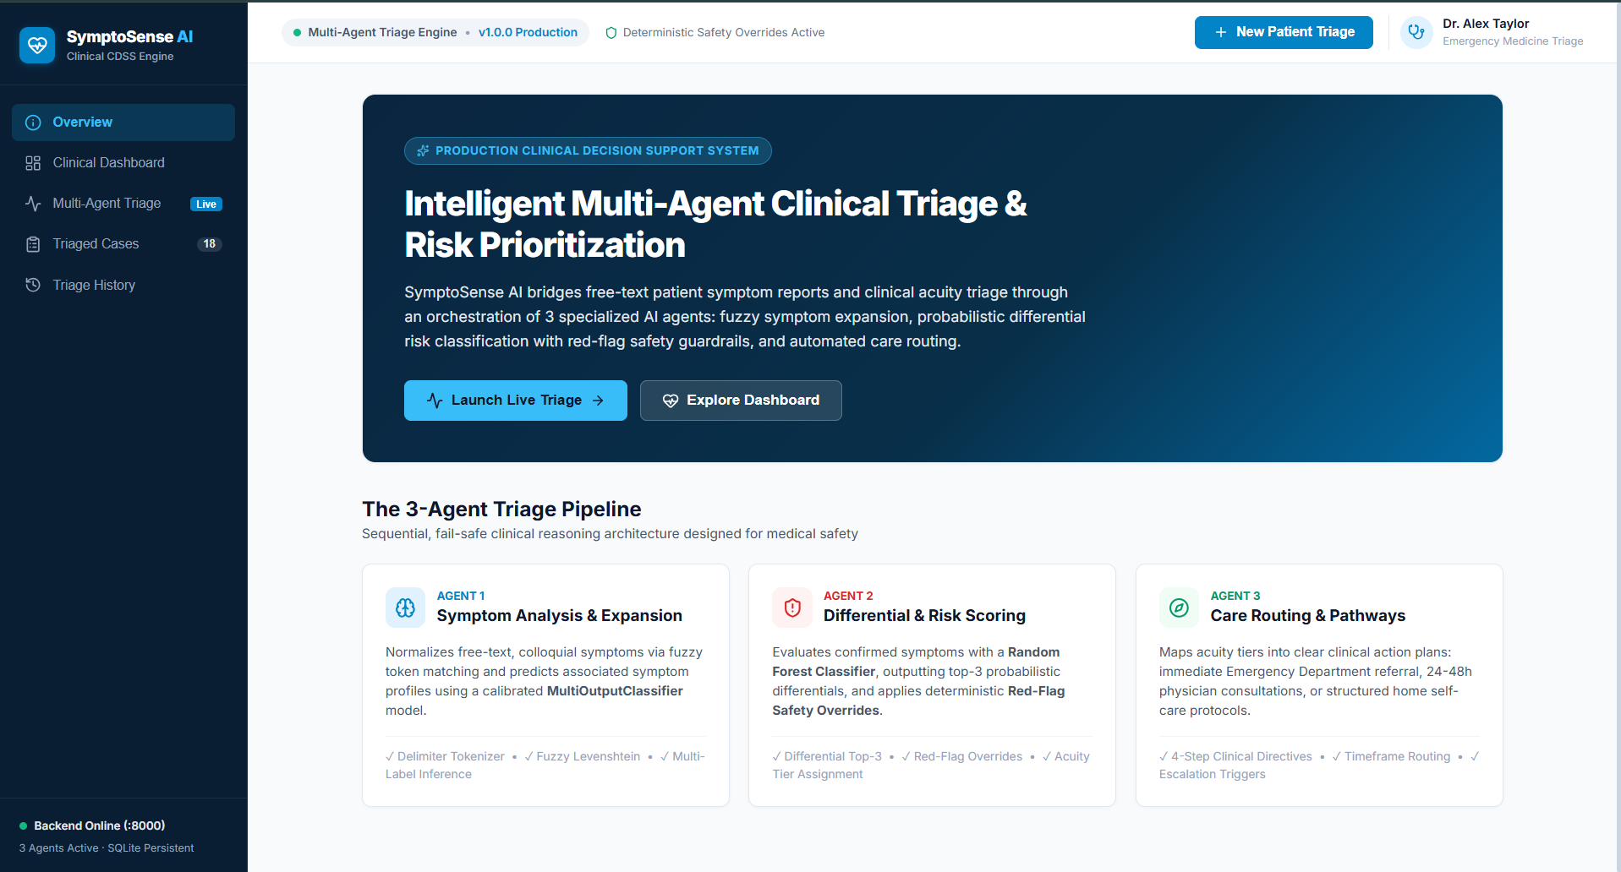
Landing view showing the 3-agent triage pipeline (Symptom Analysis, Differential & Risk Scoring, Care Routing) with a one-click entry into live triage.
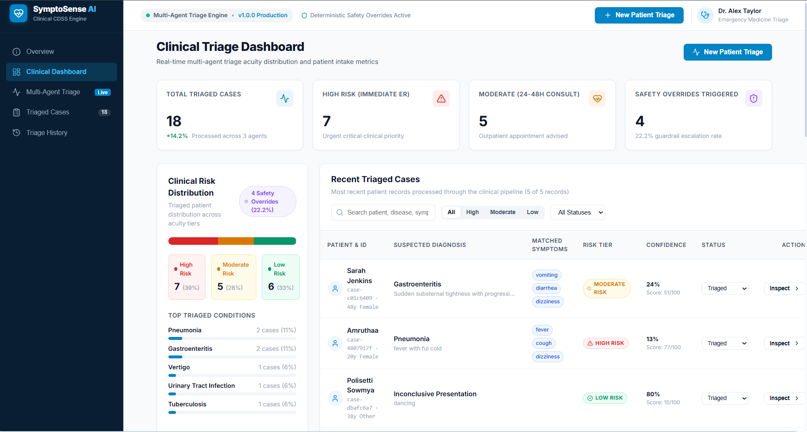
Real-time acuity dashboard showing total triaged cases, high/moderate-risk counts, and safety-override rate across all processed patients.
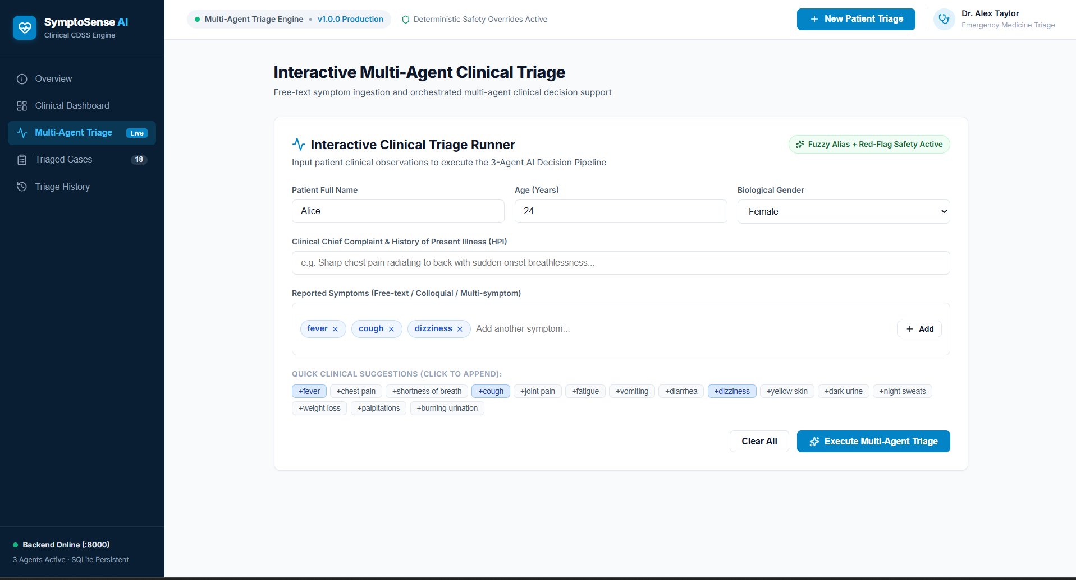
Interactive triage form where a patient’s free-text/colloquial symptoms are entered and resolved via fuzzy alias matching before submission.

- CONCLUSION & FUTURE SCOPE

Conclusion
This project set out to build an explainable, multi-agent alternative to today's rigid symptom checkers, deployed using service-oriented architecture principles. All stated objectives were met: the Symptom Analytics Agent reliably expands free-text, colloquial symptom input; the Risk Prediction Agent returns a ranked differential diagnosis instead of a single unexplained verdict, backed by an independent safety-override layer; the Care Routing Agent converts this into a clear recommendation; and all three agents run as genuinely independent, authenticated microservices behind a single API Gateway with service discovery and event-based logging. End-to-end testing confirmed the system behaves correctly, including under adversarial and emergency-pattern inputs.

Future Scope
Near-term: train the models on a larger, real-world clinical dataset obtained with appropriate ethical approval, and extend the symptom and disease vocabulary further.
Medium-term: migrate the registry, gateway, and broker to a production-grade stack (Spring Cloud Eureka, Spring Cloud Gateway, Apache Kafka), and add a clinician-facing review dashboard to validate and correct model predictions.
Long-term: integrate with hospital Electronic Health Record (EHR) systems, support multilingual symptom input, and package the frontend as a mobile application to extend reach into low-resource settings — directly furthering SDG 3: Good Health and Well-Being.

- REFERENCES
1. Ada Health — AI Symptom Assessment. https://ada.com
2. Buoy Health — AI-Powered Symptom Checker. https://www.buoyhealth.com
3. Infermedica — Medical AI Engine and API for Symptom Checking & Triage. https://infermedica.com
4. K Health — AI-Driven Primary Care. https://www.khealth.com
5. WebMD Symptom Checker. https://www.webmd.com/symptomchecker
6. Mayo Clinic Symptom Checker. https://www.mayoclinic.org/symptom-checker
7. NHS 111 Online — National Health Service, United Kingdom. https://111.nhs.uk
8. scikit-learn: Machine Learning in Python — Official Documentation. https://scikit-learn.org
9. FastAPI — Official Documentation. https://fastapi.tiangolo.com
10. World Health Organization — Sustainable Development Goal 3: Good Health and Well-Being. https://www.who.int/health-topics/sustainable-development-goals

